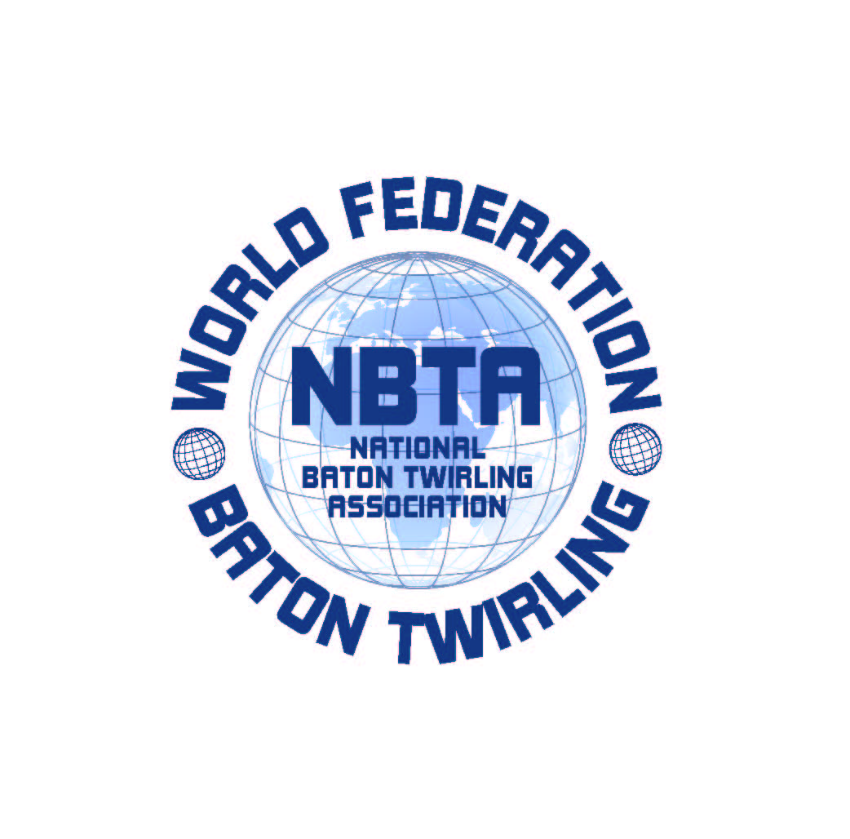

SEDE: V.le Risorgimento n°21 -26017-Trescore Cremasco (CR)
Tel.0373 / 274851 Fax 0373/291336
P. IVA 01119000196
MAIL: info@nbtaitalia.it
WEB: www.nbtaitalia.it

ASSOCIAZIONE NAZIONALE BATON TWIRLING
Dal 1983 membro della NBTA Europa e della World Federation W.F.N.B.T.A.

RESERVATION FORM
For DAILY EXTRA LUNCH AND DINNER
(only for those overnight staying outside the Village Ge.Tur.)

LUNCH DINNER Total
N. Persons N. Persons

March, 24th ________ _________ ________

March, 25th ________ _________ ________

March,26th ________ _________ ________

March, 27th ________ _________ ________

Extra Lunch or Extra Dinner costs €15,00 each one per day.

To confirm the reservation, please make payment in advance by bank transfer on:
Swift Code: BAPPIT21R33
Iban Code: IT61Q 05034 57260 000000165425

Send your reservation by e.mail at info@nbtaitalia.it , attaching this completed form and the receipt of payment bank.

